**KAMPALA PARENTS’ SCHOOL 2004**

**END OF YEAR EXAMINATION, 2018**

**LITERACY 1A- P.2**

Time: 2hrs 15 min

**NAME: _________________________AD.NO._______STREAM:____**

1. What are liquids?

__________________________________________________________________

1. Give two examples of liquids.

_______________________________and___________________________________

1. What are living things?

___________________________________________________________________

1. Draw and name one non-living thing.

_________________________________________________

1. Match correctly

Ears feeling

Nose tasting

Skin seeing

Tongue hearing

Eyes smelling

1. Why do we keep the body clean? Give one reason.

_________________________________________________________________

1. a) This is the ______________________________________

b) Why is it useful to people?

__________________________________________________________________

1. Which clouds give us rain?

__________________________________________________________________

1. Which type of weather is good for winnowing?

__________________________________________________________________

1. How do we keep the house clean? Give one way.

__________________________________________________________________

1. Draw and name any one thing we use to clean the house.

_______________________________________________

1. Why do we smoke latrines? Give one reason.

__________________________________________________________________

1. 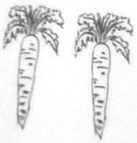Name this food that we eat.

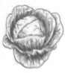

_______________________ __________________

1. How can we keep the food clean? Give one way.

__________________________________________________________________

1. Name the two sources of food.

________________________________and__________________________________

1. What is a balanced diet?

_________________________________________________________________

1. 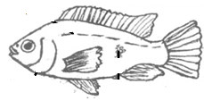How do these animals move?

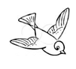a. ___________________________________________________

b. ____________________________________________________

1. Why do animals move? Give one reason.

_____________________________________________________________________

1. Match correctly

spine cobra

shell skunk

fangs porcupine

bad smell snail

1. Name any two places where plants grow.

________________________________and__________________________________

1. 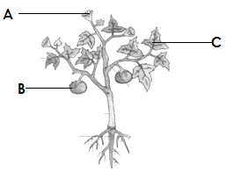Name the parts.

A ___________________________________

B__________________________________

C_________________________________

1. How do we care for our plants? Give one way.

______________________________________________________________________

1. Give one use of plants to people.

______________________________________________________________________

1. 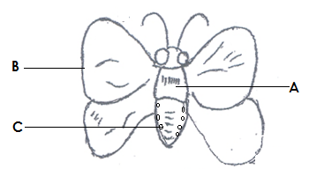Name the parts.

A ___________________________________

B__________________________________

C_________________________________

1. Name one useful insect.

______________________________________________________________________

1. How is that insect named in No.25 useful?

______________________________________________________________________

1. What do the following use to breathe

a. Man ______________________

b. plants ______________________

1. 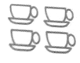Name these utensils we drink from.

_________________________________________________

1. Write one danger of dirty beddings and clothes.

_____________________________________________________________________

1. Why are we immunised? Give one reason.

_____________________________________________________________________

1. ______________________is the medicine used to immunise.
2. Draw and name one thing found in the First Aid box.

________________________________________________________________

**\*\*\*\*\*\*Merry Xmas & Happy New Year 2019\*\*\*\*\***